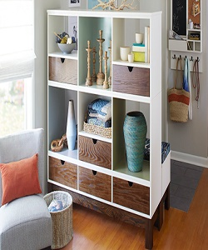

Durian Simple Divider

$109.38

Availability: In stock

**Description:**

Simple divider with 6 sections and 6 wood base drawers. this room divider can be used to define space in an open concept room, or can be set in front of a large window for privacy. Rounding out the design, metal hinges make folding and storage a breeze when not in use.